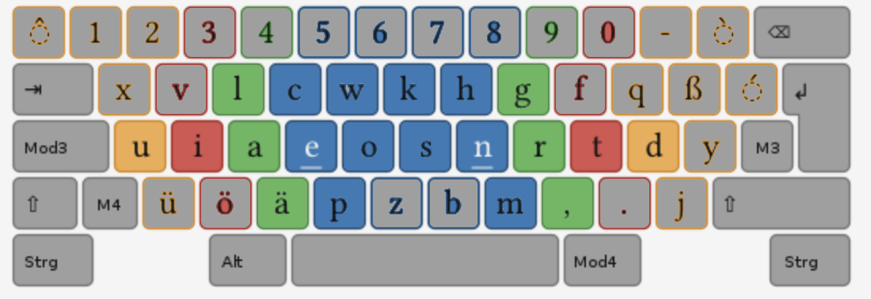aca r,r aca r,r aca r,r aca r,r aca r,r aca r,r aca r,r aca r,r aca r,r aca r,r aca r,r aca r,r

aca r,r aca r,r aca r,r aca r,r aca r,r aca r,r aca r,r aca r,r aca r,r aca r,r aca r,r aca r,r

aca r,r aca r,r aca r,r aca r,r aca r,r aca r,r aca r,r aca r,r aca r,r aca r,r aca r,r aca r,r

ace r,n ace r,n ace r,n ace r,n ace r,n ace r,n ace r,n ace r,n ace r,n ace r,n ace r,n ace r,n ace r,n ace r,n

ace r,n ace r,n ace r,n ace r,n ace r,n ace r,n ace r,n ace r,n ace r,n ace r,n ace r,n ace r,n ace r,n ace r,n

aci r,t aci r,t aci r,t aci r,t aci r,t aci r,t aci r,t aci r,t aci r,t aci r,t aci r,t aci r,t aci r,t

aci r,t aci r,t aci r,t aci r,t aci r,t aci r,t aci r,t aci r,t aci r,t aci r,t aci r,t aci r,t aci r,t

acu r,d acu r,d acu r,d acu r,d acu r,d acu r,d acu r,d acu r,d acu r,d acu r,d acu r,d acu r,d

acu r,d acu r,d acu r,d acu r,d acu r,d acu r,d acu r,d acu r,d acu r,d acu r,d acu r,d acu r,d

uca d,r uca d,r uca d,r uca d,r uca d,r uca d,r uca d,r uca d,r uca d,r uca d,r uca d,r uca d,r

uca d,r uca d,r uca d,r uca d,r uca d,r uca d,r uca d,r uca d,r uca d,r uca d,r uca d,r uca d,r

ica t,r ica t,r ica t,r ica t,r ica t,r ica t,r ica t,r ica t,r ica t,r ica t,r ica t,r ica t,r ica t,r

ica t,r ica t,r ica t,r ica t,r ica t,r ica t,r ica t,r ica t,r ica t,r ica t,r ica t,r ica t,r ica t,r

eca n,r eca n,r eca n,r eca n,r eca n,r eca n,r eca n,r eca n,r eca n,r eca n,r eca n,r eca n,r eca n,r

eca n,r eca n,r eca n,r eca n,r eca n,r eca n,r eca n,r eca n,r eca n,r eca n,r eca n,r eca n,r eca n,r